TU/e Mechanical Engineering Program

Design-Based Learning
1st Quartile 2022-2023

Truss Structure Challenge

Tutor: Lou Hacking
DBL Group 5 :
Aurele Caucheteux [1788574], Luchezar Chardakov [180513], Lucas van Haperen [1794019], Quinten Dam [1868179], Marieke Joosten [1794272], Marietta Kaloudi [1824619], Simon Rosenberg [1844636], Tobias Wejbora [1785486]

Eindhoven, 30th of September 2022
Contents

List of symbols 2
Introduction 3
Conceptual design 4
The design process: 4
Primary features of the ideal final design: 4
Improving the first designs 5
Assumptions that were made in the design process: 6
Failure mechanisms: 6
Design details 7
Design 1: 7
Design 2: 8
Design 3: 8
Conclusion and recommendations 11
References 12
Appendix A 13
Force values for figure 10, 11 and 12. 13
Appendix B 14
Calculations Design 1: 14
Forces in Design 2: 15

List of symbols

All the mathematical symbols that are used in this report are listed on Table 1 below and Figure 1 is a visual representation of the trigonometric formulas.

Table 1. List of mathematical symbols and notations
Mathematical symbol | Purpose
$$\sin\left(x\right) \left[-\right]$$ | The ratio between opposite side and the hypotenuse in a right-angled triangle (See picture underneath this table)
$$\cos\left(x\right)\left[-\right]$$ | The ratio between adjacent side and the hypotenuse in a right-angled triangle
$$\tan\left(x\right)\left[-\right]$$ | The ratio between the opposite side and the adjacent side of a right-angled triangle
$ϕ$in radians $\left[-\right]$ | Angle between two members or forces
$$F \left[N\right]$$ | Force
$$H_{A}, V_{A}\left[N\right]$$ | Reaction forces about a certain point, in this case in horizontal and vertical direction, around point A.
$$C_{B},T_{B} \left[N\right]$$ | Internal forces in a member, in this case a compression force and a tension force around point B
$$L \left[m\right]$$ | Length
$$E \left[Pa\right]$$ | Young modulus
$$I \left[m^{4}\right]$$ | Area moment of inertia
$$A \left[m^{2}\right]$$ | Area
$$ν \left[-\right]$$ | Poisson’s ratio

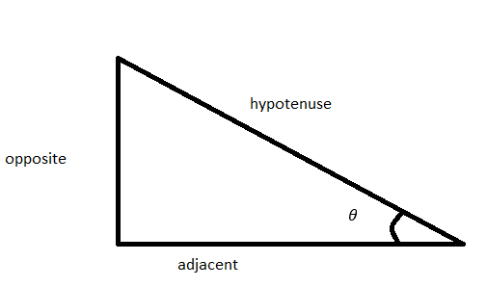
Figure 1. Right-angled triangle for the trigonometric expressions

Introduction

Even though they might not be noticeable, truss structures play a significant role in our day-to-day lives. Bridges, radio towers, electric pylons are all truss structures that connect our world. On its own, a truss structure is a rigid structure which consists of members, connected by nodes. Trusses usually consist of triangular shapes that altogether allow to carry huge loads in structures that can go way above a human scale.
In this case, the city council of Maastricht wants to organize a series of open-air concerts. Those concerts are taking place by the river Maas, having as a background the historic town wall which will be a part of the stage decoration of the event. A company named ALL STAGES B.V. will oversee the completion of the decorations that shall be present at the event. However, the lack of experience in constructing cranes led them to seek help from the Department of Mechanical Engineering at TU/e to construct the truss structure.
The purpose of this project is to conclude a design that will outperform the competing crane model by at least 10% when considering the maximum load the truss structure can sustain, which in this case is 3000 [kN]. So, the main goal is to convince the organizers, through well-supported arguments with the subsequent calculations provided, that the final design produced will be better than the concurring design. To achieve that, there are specific requirements, preferences and constraints while building a crane that one must consider. In this case, the crane should be able to withstand the load of the decoration without putting the historical wall at risk of damage, which implies failure of the truss structure. This should be done with the least amount of money and material. And last, there are also some constraints: There needs to be some decoration at the historic wall of Maastricht, however it is not allowed to put anchoring points in the monument, because it because it would get damaged. Therefore, the crane should be anchored and built behind the wall, with an arm reaching above the wall. Lastly, the crane cannot block the horizon as displayed on Figure 2 below.
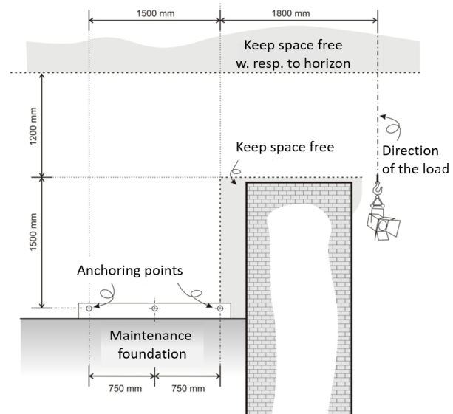

Figure 1: Visualization of the constraints and requirements of the crane

To achieve the goal of designing a good-structural truss, it is important to remain close to the seven design phases. First, the main problems were made clear. Indeed, physical concepts such as buckling or plastic deformation would have to be considered. A brainstorming procedure was then conduced, where each of our members threw their idea on paper to try and find clever solutions to our problems. Some of those ideas were not practical, or realistic. Our team therefore sorted them out and only the best ideas were kept for the third phase of design. From there on all the necessary calculations were conducted to refine the design into a final 2D sketch with the correct dimensions.
The report follows a linear structure, first starting with our conceptual designs and first steps and then moves towards more refined 2D sketches. It will then go deeper into the details about our thought process to reach our final sketches, with calculations and scientific explanations alongside them. We will then conclude on our current progress. An Appendix with extra documentation is available at the end of the report.

Conceptual design

The design process:

Initiating a project that requires producing a final design requires a continuous contribution of all the members that ultimately will lead to producing a final design that will have all the prominent features that a truss structure should have and be the best possible output of the team. The second step in the design process, after establishing the main problems, was to brainstorm a variety of designs. Moving forward, the main goal was, by comparing some of our first designs, to discover which members are most likely to fail first and what can be done to reduce the high tensile stresses and compressions that would cause our truss structure to fail. The third phase of the design process was to choose some of the best designs from the second design phase and work on improving them, taking into consideration that the new design will be statically determinate.
After doing so, the next step was to choose two to three designs as the main ones to focus on and calculate the internal forces on the members and additionally test some of these 2D designs on Marc Mentat to acquire more data about possible deformations about each one of them. Finally, a single design was chosen that would be used as a base for future 3D models. A crucial step in this process was reviewing the requirements, constraints, and preferences the final design had to comply with. One of the most important requirements was to keep the free space around the monument. When it comes to the constraints, considering the amount of building materials available and the anchoring points in the foundation was also important, however not for the first design phase of the 2D designs that is going to be discussed below.

Primary features of the ideal final design:

The selection of the initial designs was based on some criteria and key features that were discussed in the meetings, which the final design should also incorporate, and are listed below: First, the main geometric shape that should be used in the 2D designs that followed would be triangles because the load applied to its corners can be evenly distributed amongst its sides. Furthermore, there should be enough support inside the arm of the crane to prevent it from failing due to the high tensile and compressive forces and instead have them evenly distributed amongst more members. Another crucial point was to effectively use the anchoring points that are available. This means that which anchoring points should be used is something we should think about so that the base of the crane is supported enough to withstand the weight of the arm and of the added load in the front end of the arm. Moreover, it is of equal importance to find a way to support the base of the truss structure in a way that it minimizes buckling. Figures 5 and 6, more specifically, illustrate two of the most effective design choices that could be tested in the future. Lastly, the material that would be used in each design should be also considered. In this case, design No. 3 displayed in Figure 4 requires more building material which is a limiting factor when it comes to building the crane. Therefore, the remaining three designs in Figures 3,4 and 6 were chosen because alongside their other advantages they make more logical use of the materials, which complies with the technical regulations given.
Some of the first designs that were proposed are shown below in Figures 3 to 6, and some of their key features and drawbacks will be analyzed in the following sections. However, this early in the design process there was one important factor that was neglected, and this was if the designs were statically determinate or statically indeterminate, which would be of high importance in the future when we will have to calculate the internal forces in the members and the maximum load the structure can sustain before it begins to deform. So, the designs illustrated on the Figures 3 to 6 below are the best designs that were produced by the group while still being on the preliminary stages of the design process.
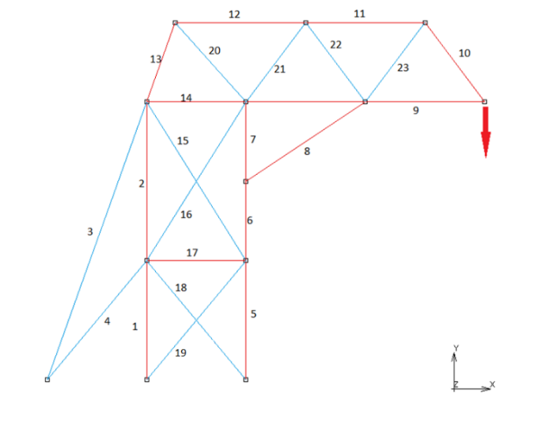
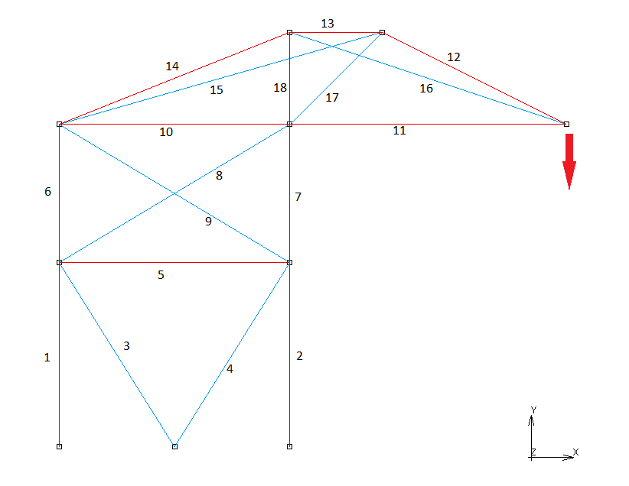
In the following figures the members in red represent the corner profiles and the members in blue represent the strips. In the current state, corner profiles are used more often that the strips, as strips are mostly used as the zero-force members in the truss structure. However, considering the restriction in material, this might be something that has to be considered in the future. For now, however, we will not take this material restriction into account, as this design step’s goal is mostly about having innovative ideas and concepts that could be used in later designs. In the second design phase, the limitations in terms of material are considered.

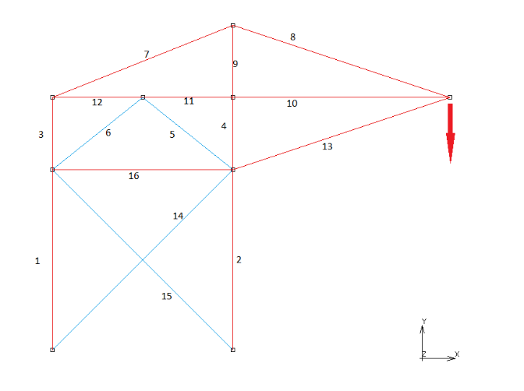
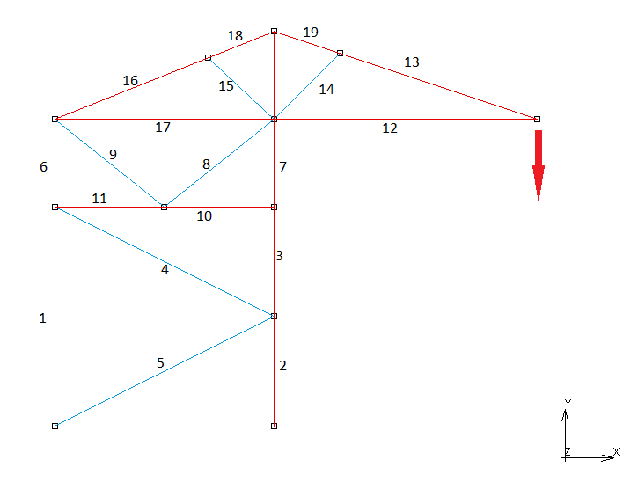
Figure 3. Initial Design No. 1 Figure 4. Initial Design No. 2

Figure 5. Initial Design No. 3 Figure 6. Initial Design No. 4

Improving the first designs

Even though these designs were from the preliminary stages of the design process, there are some aspects worth studying and improving that could eventually end up in the more “in depth” designs. For example, design No. 2 in Figure 4 already looks into making members in the forward arm as short as possible to minimize buckling. This feature will eventually be used in our final 2D sketch. Design No.3 illustrated in Figure 5 differs from the others in terms of the base as it was an attempt to place the two supporting beams forming a triangle in the middle of the front member of the base. Consider this an extension of the idea formed in Design 1. Indeed, putting the members in such a way allows to cut in half the length of the front member. Just like the feature explored in design 2, it will be a key feature of our final design.
On the other hand, Design 4 illustrated in Figure 6 is an example of a design we couldn’t use due to constraints. Indeed, while adding a support member would seem like a promising idea on paper, it is something that can hardly be done in the context of the project, as we need to care for the forbidden zone. Consequently, this idea did not make it to our final design.

Assumptions that were made in the design process:

Throughout the process of improving our designs and working towards a final design, a few key assumptions were made so that we would be able to work more effectively on the project. A first hypothesis was that the front beam of the base will buckle first in the middle. Thus, buckling would be an ongoing issue and as we try to increase the load and would therefore be a bottleneck we have to circumvent.
Another assumption that was made was that the anchoring points are not going to be possible failing points. This is because the structure is built in such a way that the anchoring points are more rigid and solid than other joints, for example, two bolts are used in the members attached to the anchor plates. Because of this assumption we also assumed that the crane is strongly attached to the ground and will not tip over due to the external loading in the arm of the crane.

Failure mechanisms:

While designing a crane truss structure, one must consider which would be the points where the structure is most likely to fail. When having a clear idea where the problem areas are, better decisions can be made when improving the design. In this case there are three main failure modes: buckling in the base, buckling in the arm, and breaking of the members.
The beams in the base of the structure will be under a lot of compression. To prevent buckling it is essential to first try to divide the forces over multiple members, this way the individual members are under a lot less stress and the structure can withstand more load. Another way to minimize the chance of buckling in the base is to add zero-force support beams to shorten the compressed beams. These beams will not share the load, but they will provide the necessary stability. The same goes for the compressed beams in the arm. Long members are required to bridge the wall, but this creates a problem area. Indeed, the long members that are under compression are very prone to buckling. By adding zero-force support members to shorten the members, this risk will significantly decrease.
The last of the three important failing mechanisms to consider when designing the crane is the breaking of the beams that are in tension. This is not something that is likely to be the main flaw in a design, but it is something to keep in mind. The best way to reduce the chance of failing is to divide the forces over multiple beams, so there won’t be too much force on one member. A way to do this is to play with the angle of the triangles that makes our truss, to change force repartition more equally between the x and y components. The reasoning behind finding the optimal arrangement will be explained in the following section.

Design details

Design 1:

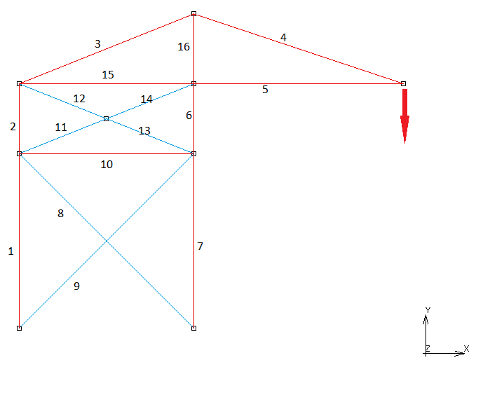
The following design, illustrated in Figure 7, is a design from the most recent proposals that were made after taking into consideration some important aspects and requirements that our structure has to have. To begin with, the structure should be statically determinate in order to be able to perform any force and stress calculations in its members. More specifically, we can conclude that this design is statically determinate as the number of the members ($N_{m}$) plus the number of the reaction forces ($N_{r}$) equals two times the number of the joints ($N_{j}$).
$N_{m} + N_{r} = {2N}_{j}$ (1)

Figure 7. Intermediate design 1
This design consists of two fundamental components the base and the upper part of the crane, the arm. Furthermore, the base is supported by two diagonal zero-force members which, despite the fact that they do not distribute the force to other members, provide support to reduce the buckling effect on the two vertical front and rear members of the base. Moreover, even though adding support inside the arm of the crane would reduce the tensile stress in the rear end of the beam, in this design to minimize buckling the weight of the arm of the crane is as little as it could be in order to reduce the compression in the front end of the base.
However, some of the main disadvantages that would put the design at risk of failure can be seen. First of all, buckling, especially in the front end of the base, will remain a concern despite the efforts to minimize its effect, considering the load that will be held by the crane, as we want it to reach the highest value possible. Moreover, member 3 is the most susceptible to fail under tension while the load increases. After establishing the design and its main features and drawbacks, the next step was to calculate the forces on each member. The hand calculations for this design can be found in the Appendix B: Calculations 1, and the forces for each individual member can be seen in Table 2.
In conclusion, the member that is under the most stress is member 3 which is loaded in tension and member 4 which is loaded in compression. After testing the 2D structure on Marc Mentat the results revealed that the member that is most likely to buckle is indeed the member 4 which is loaded in compression and will cause the arm of the crane to tilt forward. Some crucial features that are worth improving moving forward on the design process are supporting internally the arm of the structure and to avoid the larger scale deformation. Also, keeping in mind that the truss structure should be modelled eventually as a 3D design, it is important to find ways of adding supporting members for the members 8 and 9 that will be connected in the middle of the member to prevent it from buckling.

Design 2:

Figure 8 shows the second proposed 2D design, this design is based on several points that would probably make the truss structure more stable. For example, one of the ideas was moving the point of gravity more towards the back of the structure to make the crane more stable and less likely to tip over. Furthermore, making use of triangles inside of the structure was also important because they will help to distribute the forces the best among all the different members. After the designs were made, the forces on every single member were calculated to see if the truss would be strong.
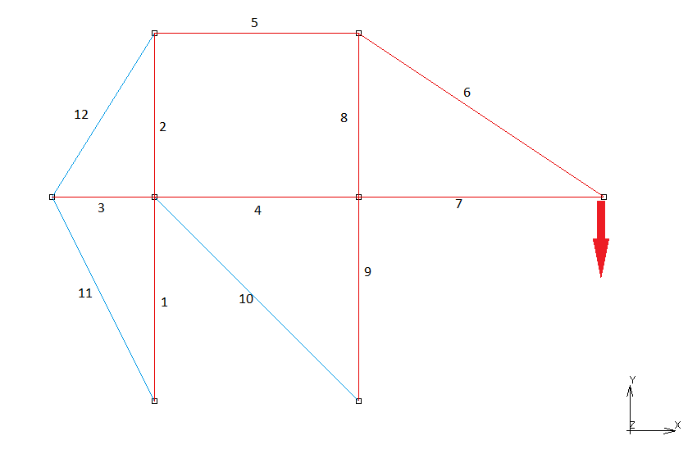
Figure 8. Intermediate Design No. 2
After the forces were calculated a conclusion was made that the next design we will present would work better when comparing the forces on the different members in the two designs. It also revealed that certain earlier thoughts and ideas would not have an influence on the outcome of the design. For example, the idea to move the point of gravity further back would not matter because it is almost impossible for the truss structure to tip over when you make use of the anchoring points. Also, the fact that the back triangles, which do not have an influence on the results, will use loads of extra materials makes this idea even more sub-optimal. The biggest downside of this truss structure is that the middle square will probably snap because of the forces working on it. This will cause the entire structure to fail and collapse. To prevent this from happening extra members are needed but that can’t be done because of the limited amount of building materials that we have to our disposal. However, a good feature of this design should be remembered: the front arm is made to be as short as possible. This is a great idea that will increase the resistance to buckling of the front arm.

Design 3:

In our Final 2D design, the approach was to create a simply yet structurally stable design since the earlier designs seemed too complex to be applied in real life scenarios. Referencing Wikipedia, the equations in Figure 9 will be used to calculate the Second moment of Area of the steel corner profiles. From that, we will have a way to express critical buckling load in function of the length of a given beam. Our minimum target load will be 3500 Newtons.
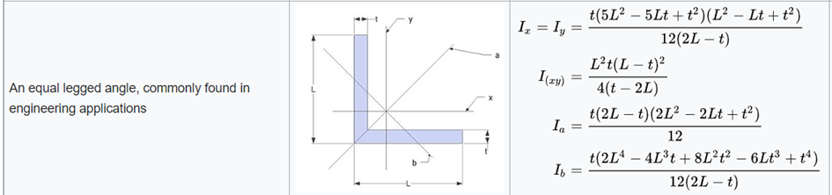
Figure 9. Formula of the second moment of Area (Wikipedia, n.d.)

Here we have $t=0.002$and $L=0.015$, in meters. These values can then be plugged into equation $I_{b}$, since axis b is weakest in terms of resistance to bending. Hence, the given value for $I_{b}$.
$$I_{b}=4.8×{10}^{-10} [m^{4}]$$
Furthermore, since this design is a truss structure, the joints are pinned. According to lecture 2 of course 4GA00 we can calculate the maximum buckling force with the following formula:
$F_{b}=\frac{π^{2}EI}{L^{2}}$ (2) (Anderson, 2019)
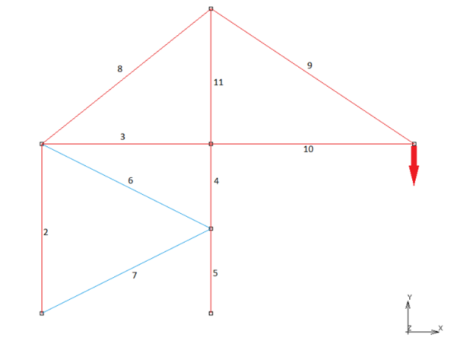
Where $F_{b}$ is the bucking force, $I$ is the second moment of area, $L$ is the length of member and $E$ is the Young’s Modulus of Steel.
Figure 10. First version of the third design
This equation describes the buckling force as a function of the given length of a member in compression. Utilizing these equations, we can analyze our design. The drawings were designed using the Website “Valdivia” which also allows for the calculation of the individual forces of each member. (valdivia, n.d.)
The first version of the third design wave is shown in Figure 10 and the respective force values in Table 1 (see Appendix A).
Given the forces of each member, the maximum load can be calculated. For Steel, the Yield Stress is equal to 200 [MPa]. As the Cross-Sectional area of a Corner profile is $5.6*{10}^{-5} {[m}^{2}]$, it gives us a maximum tensile stress of 11.2 [kN], and in an analogous manner, 6 [kN] for a strip. The biggest tensile load here is on member 8, and therefore it would allow for a maximum load of $\frac{11200}{2029}=5520 [N]$.
This result would be amazing; however, the buckling force must still be considered. The longest member under compression is member 10 with length of 0.6 meters. Thus, using equation (1) to calculate it’s maximum buckling load, a result of 2700 [N] is obtained.
This design must still be improved since this member would buckle before the minimum target load of 3500 [N]. To improve member 10 will be made smaller by adding a zero-force member (Member 13, Figure 9), which ultimately splits member 10 into two members 10 and 12. With this new design the maximum buckling load can be calculated.
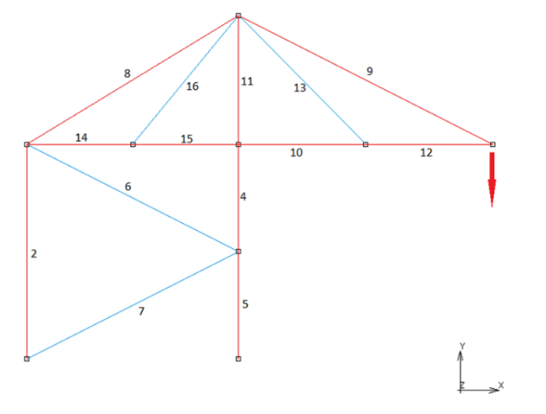
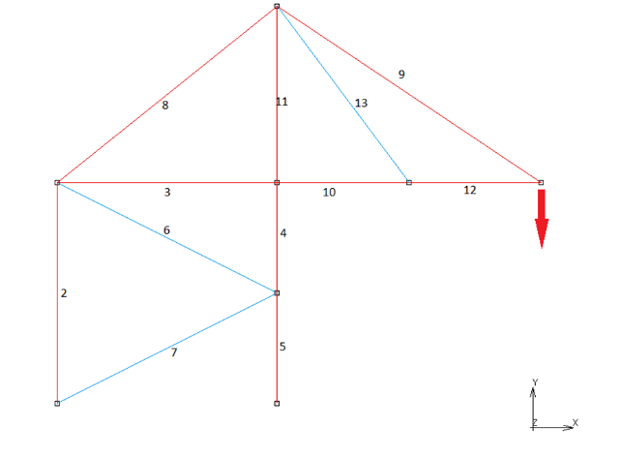
Plugging in the designs value of $L$ into equation (1), a maximum buckling load of 10 900 [N] is obtained. Furthermore, the load in the newly created members 10 and 12 is -1.5F. This is because member 13 is a zero-force member, meaning that members 10 and 12 will have the same force as member 10 in Figure 8. Thus, a maximal load of 7260 [N] is found by dividing the maximum bucking load by the force in members 10 and 12, $\frac{10900}{1.5}=7260$ (note that positive 1.5 is used since a negative maximal load cannot exist).
Figure 12. Final design
Figure 12. Final design
Figure 11. Intermediate design 3

These steps now must be repeated on all members bottlenecking our design. This way, our structure will reach the minimum target load of 3500 [N]. To do so, member 11 was shortened and another zero-force member (Member 16, Figure 10) was added. This addition also made member 13 split into member 14 and 15.
After these modifications, a final design (see Figure 12) has been reached. Since the first version of our design the following modification were made; member 11 was shortened to 0.3 meters, members 4, 5, 14 and 15 were shortened to 0.25 meters and members 10 and 12 are now 0.3 meters.
In this design, the member receiving the most compression in regard to its length is member 11, making it the critical member, failing at 4950 [N]. Regarding tension, the member with the biggest load is member 9, which starts experiencing plastic deformation at 5005 [kN]. Our critical load is therefore 4950 [N]. The design is simplistic yet structurally stable, ultimately keeping building costs to a minimum. It of course complies with constraints and meets the requirements as shown by the aforementioned calculations.

Conclusion and recommendations

In conclusion, the final 2D design that is created satisfies a great part of the given requirements, preferences and constrains (RPC). These are satisfied because some of the RPCs were that the model should be able to carry at least 10 % more load compared to the original design. The design was on average able to carry 3000 newtons, while the created design can carry an estimated maximum of 4950 [N] and therefore this first requirement is satisfied. Another preference given by ALL STAGE B.V. is to make use of as little material as possible in order to save money, this is achieved because the created 2D design is an extremely simplistic design which does not use a lot of materials compared to the original design that was given.
Through many calculations it was concluded that the buckling effect that was present in the long members under compression, was the main area of improvement. This was fixed by adding more zero-force support members to reduce the overall length of the long arm which in return reduced the buckling forces. Members under tension are not susceptible to this phenomenon and therefore were not looked at in such depth as in the members under compression. It is also relevant to point out that for the zero force members steel strips were used since their only job was to stabilize the long members and don’t experience such loads as the corner strips that support the whole load and structure.
The effect of buckling is crucial when analyzing the maximum load that a certain design can hold but might not be the only determining factor of its overall strength. As seen from the results gathered from the calculations, the member starts to experience plastic deformation at 5005 [N] which is remarkably close to the maximum load that can be held if buckling is considered (4950 [N]). It is interesting to point out that these values are close, because a good balance between the buckling and tension forces has been reached. This however is not the case with the design in Figure 8 where the maximum load due to buckling is taken into consideration with a value of 2700 [N] which is substantially lower compared to the maximum load if failure is decided by elastic deformation due to tension. From this it can be concluded that the final design has been greatly improved compared to past prototypes of the earlier design phases and is also greatly optimized and balanced.
For the future, all the other requirements, preferences and constrains given by ALL STAGE B.V. also needs to be considered. To do that the current final 2D model will be transformed into a 3D model which will be tested and analyzed using the computer program Mark Mentat. With the results, the weak points of the design will become visible and can be improved to create the best design possible for ALL STAGE B.V. The next step overall is to convert the chosen design from to a 3D model, using as a basis the 2D design and finding efficient ways to support the truss structure using internal support members.

References

“Second Moment of Area.” Wikipedia, Wikimedia Foundation, 2 Sept. 2022, https://en.wikipedia.org/wiki/Second_moment_of_area.
“Trusses.” Design Technology, https://designtech.be.uw.edu/structures/str-trusses/.

Appendix A
Table 1.
$$i$$ | $$N_{i}$$
2 | 1.20F
3 | -1.50F
4 | -2.20F
5 | -2.20F
6 | 0.00F
7 | 0.00F
8 | 1.92F
9 | 1.8F
10 | -1.5F
11 | -2.2F

Force values for figure 10, 11 and 12.

Table 2.
$$i$$ | $$N_{i}$$
2 | 1.20F
3 | -1.50F
4 | -2.20F
5 | -2.20F
6 | 0.00F
7 | 0.00F
8 | 1.92F
9 | 1.80F
10 | -1.50F
11 | -2.20F
12 | -1.50F
13 | 0.00F
13 | 0.00F

Table 3.
$$i$$ | $$N_{i}$$
2 | 1.20F
4 | -2.20F
5 | -2.20F
6 | 0.00F
7 | 0.00F
8 | 2.33F
9 | 2.24F
10 | -2.00F
11 | -2.20F
12 | -2.00F
13 | 0.00F
14 | -2.00F
15 | -2.00F
16 | 0.00F

Appendix B

Calculations Design 1:

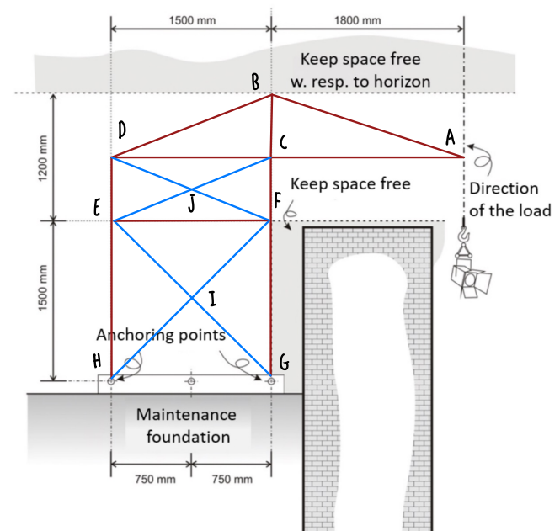
Shown below are the calculations of the forces on each member. A positive sign indicates a tensile force, and the negative sign indicates a compressive force. The the positive x direction is always to the right and the positive y- axis direction is upwards.
Equilibrium at Point A:
$$α=\tan^{-1}{\frac{600}{1800}}=18.4°$$

$$ΣF_{y}=0=T_{AB}\sin{α}-F$$
$$T_{AB}=3.2F$$
$$ΣF_{x}=0=-T_{AB}\cos{α-T_{AC}}$$
$$T_{AC}=-3.0F$$
Equilibrium at Point B:
$$β=\tan^{-1}{\frac{600}{1500}}=21.8°$$

$$ΣF_{y}=0=T_{AB}\cos{β}-T_{BD}\cos{β-T_{BD}}$$
$$T_{BD}=3.27F$$
$$T_{BC}=-2.22F$$
Equilibrium at point C:
$$ΣF_{x}=0=T_{CD}=T_{AC}=-3.0F$$
$$ΣF_{y}=0=T_{FC}=T_{BC}=-2.22F$$

In a comparable manner, the equilibrium equations were used to calculate the remaining points (points D to I), the remaining internal forces on each member can be calculated and the results are shown below.
𝑇_{𝐷𝐸} = 1.21𝐹, 𝑇_{𝐸𝐻} = 1.21𝐹, 𝑇_{𝐹𝐺} = −2.22𝐹,
𝑇_{𝐸𝐹} = −𝐻_{𝐴} = −2.22𝐹 and 𝑇_{𝐹𝐺} = −𝐻_{𝐴} = −2.22𝐹

Forces in Design 2:

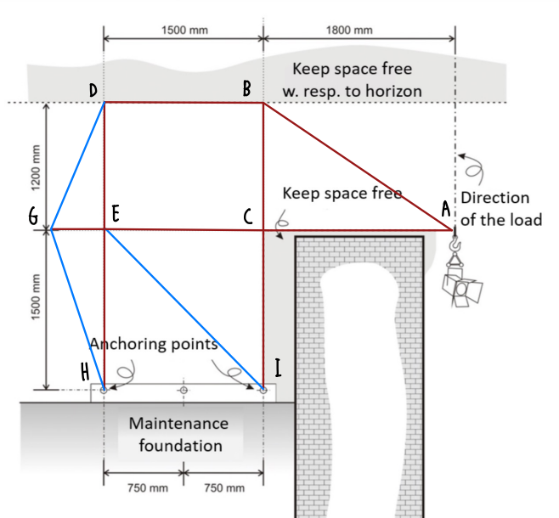

$T_{AB}=1.8F$, $T_{AC}=-1.5F$, $T_{BD}=1.0F$, $T_{BC}=1.5F$,
$T_{CE}=1.8F, T_{AC}=1.8F$, $T_{CI}= 1.5F, T_{BC}=1.5F,$
T _{DG} = 1.9F, T _{DE} = -1.6F, T _{GE} = 0.8F, T _{GH} = 1.9F,
T _{EI} = -1.0F and T _{HE}= -0.9F

